BACKGROUND
Oropharyngeal squamous cell carcinoma (OPC) is one of the fastest-increasing cancers in the United States. It arises from the tonsils, base of tongue, soft palate, and posterior pharyngeal walls and now accounts for a growing proportion of head and neck malignancies. Approximately 60–70% of new OPC cases are attributable to human papillomavirus (HPV).¹ The incidence of HPV-positive (HPV+) OPC has risen steadily since the 1980s,² and in the past decade, HPV+ OPC has surpassed cervical cancer as the most common HPV-related malignancy in the country.³ Oral oncogenic HPV infection is a necessary precursor to HPV-associated OPC and therefore represents a crucial target for primary prevention through HPV vaccination.^{4,5}
HPV vaccination has been proven highly effective in preventing persistent infection and associated malignancies. Since its introduction, population-level studies have shown significant declines in cervical, anogenital, and oral HPV infections among vaccinated cohorts, confirming durable immunogenicity and broad cancer prevention benefits.⁶ Yet, HPV vaccination remains underutilized among adults, particularly among men, despite their growing burden of oropharyngeal cancers. Only about one-third of adult males in the U.S. have completed the HPV vaccine series, compared to nearly half of females, leaving a substantial portion of at-risk adults unprotected.⁷
Veterans represent a population at uniquely high risk for HPV-related malignancies. Compared with the general population, Veterans are disproportionately male, older at the time of entry into VHA care, and more likely to smoke, live in rural and medically underserved regions, or experience occupational and environmental exposures such as burn pits. ^{8,9} More than one-third of enrolled Veterans reside in rural or highly rural counties, where access to specialty care and preventive services, including vaccination, is limited by geographic distance, workforce shortages, and transportation barriers.⁸ Rural Veterans have lower rates of cancer screening, later stage at diagnosis, and poorer survivorship outcomes, trends that may extend to HPV-related cancers.⁸ They also carry higher rates of comorbidities and mental health conditions that may complicate preventive care delivery. Epidemiologic analyses using VA and SEER data suggest that the increase in OPC incidence among Veterans is more than three times greater than in the general population.¹⁰ Despite these elevated risks, HPV vaccination uptake in the VHA remains strikingly low, with rates significantly below those observed in civilian populations (Figure 1). Emerging internal data indicate that vaccination rates are lowest among Veterans in rural VISNs, further amplifying geographic disparities in preventable cancer burden. This under-vaccination portends a persistent and potentially widening gap in HPV-associated cancer prevention within the VHA.
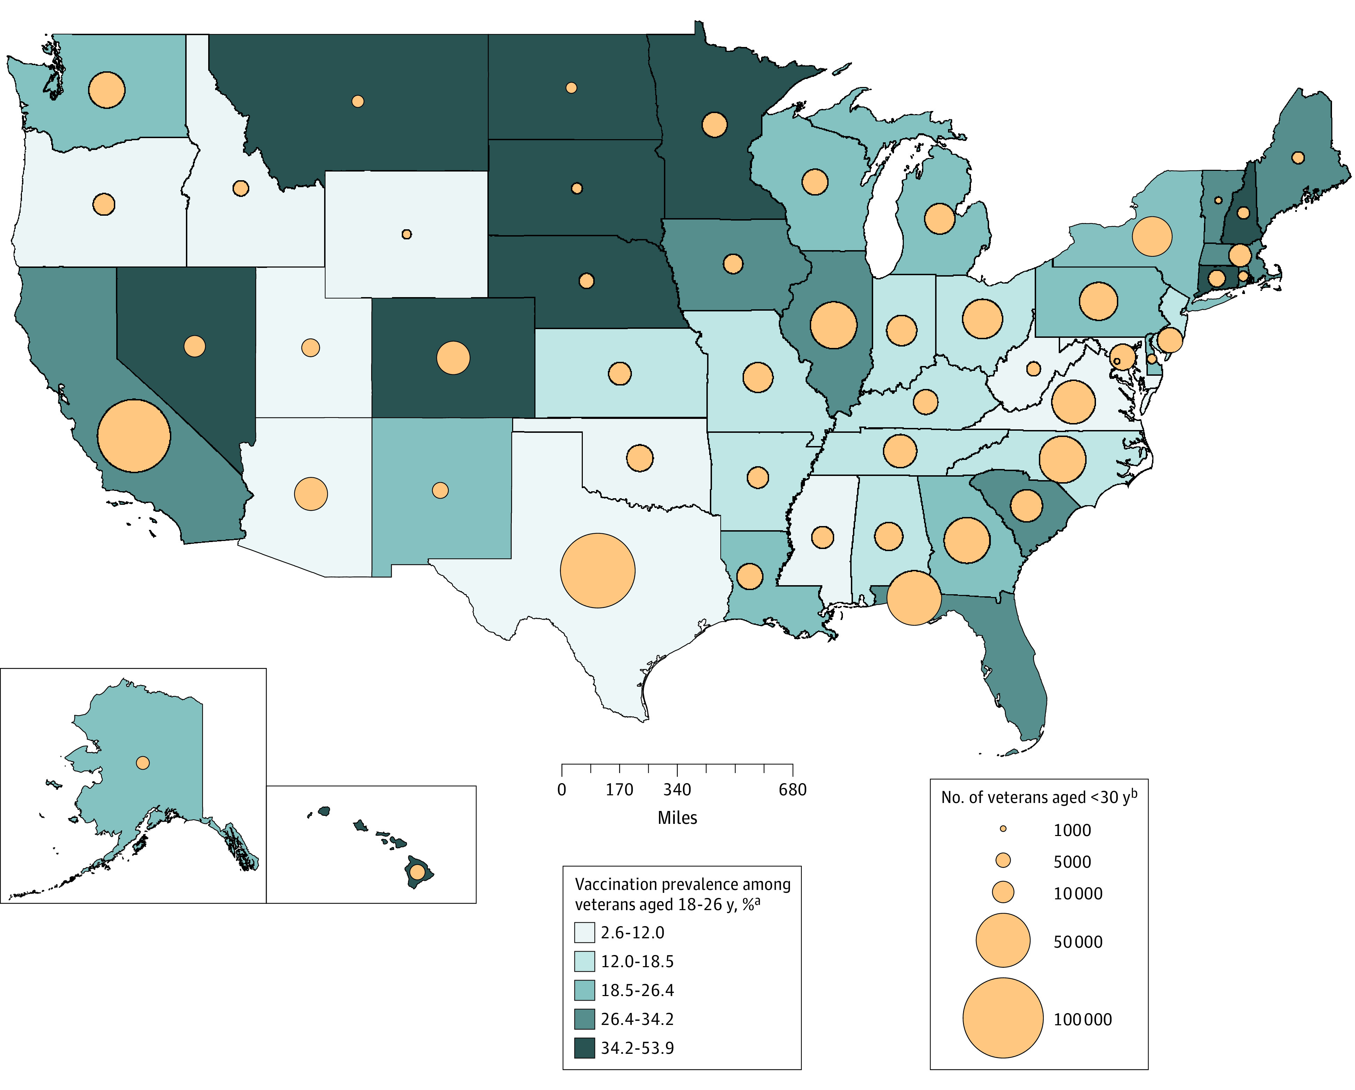
Figure 1. Geographic variation in HPV vaccination prevalence among Veterans aged 18–26 years and distribution of Veterans under 30 years of age across U.S. states. The map illustrates substantial regional variation in HPV vaccination coverage and highlights rural VISNs with lower prevalence and smaller populations of younger Veterans, underscoring opportunities for targeted, geography-specific vaccination initiatives within the VHA.
Although HPV vaccination is universally recommended through age 26, more recent guidance from the Centers for Disease Control and Prevention (CDC) endorses vaccination for mid-adults aged 27–45 based on shared clinical decision-making.⁶ The rationale for this selective approach reflects data from cost-effectiveness models developed in general U.S. populations: vaccinating mid-adults confers smaller marginal health gains at substantially higher costs per quality-adjusted life year (QALY) than adolescent programs, largely because of prior HPV exposure and existing herd immunity from younger cohorts.^{11,12}
Nevertheless, several recent analyses demonstrate that extending vaccination to adults may provide meaningful population health benefits under certain circumstances. In a global meta-analysis, Pratama et al. (2024) found that universal gender-neutral vaccination, including both boys and men, was cost-effective in high-income countries, with pooled incremental net benefits averaging US $9,370 per vaccinated individual for prevention of HPV-associated oropharyngeal cancer.¹³ Other studies have modeled specific high-risk populations, finding that adult vaccination can remain economically reasonable when baseline HPV prevalence is high or when targeted to groups with elevated infection or cancer risk, such as men who smoke, individuals with immunocompromising conditions, and those with delayed access to preventive care.^{11,14,15}
Importantly, nearly all existing cost-effectiveness studies use general-population assumptions and fail to account for the demographic, behavioral, and clinical characteristics unique to Veterans. Veterans often experience delayed engagement with preventive services, receive care within an integrated health system, and differ in baseline risk for HPV infection and OPC onset compared with civilians.^{9,16} These gaps are especially relevant for rural Veterans, who rely heavily on community-based outpatient clinics (CBOCs) where vaccination infrastructure and outreach capacity may differ from urban medical centers. Quantifying rural-urban disparities in HPV vaccination across VISNs is therefore critical to designing equitable prevention strategies. For example, later age of first VHA encounter, higher smoking prevalence, and the absence of any screening test for oropharyngeal cancer could increase the relative value of vaccination in this population by preventing disease that otherwise would be detected only at late, costly stages.^{10,16}
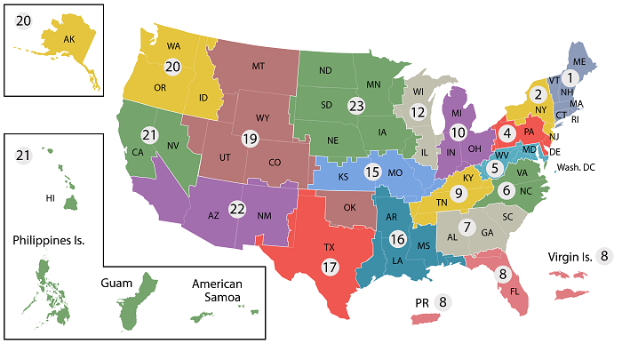
Figure 2. Veterans Integrated Service Networks (VISNs) in the United States. The Veterans Health Administration is divided into 18 regional VISNs that coordinate and deliver care across geographic areas. Each VISN oversees healthcare access, resource allocation, and preventive initiatives, such as HPV vaccination, tailored to local Veteran populations.

From a health system perspective, the potential economic impact on the VA is substantial. Treatment for advanced OPC is expensive and associated with significant long-term morbidity, functional loss, and disability, generating considerable cost to the VHA in both direct care expenditures and indirect costs related to service connection and disability compensation.^{16,17} Modeling these downstream costs in relation to the investment required for expanded vaccination is critical to understanding the potential budget impact and return on investment in prevention.
In summary, HPV-associated OPC is an emerging cancer epidemic among Veterans. Vaccination is the only proven primary prevention strategy, yet it remains markedly underutilized in this high-risk group. Existing cost-effectiveness models, developed primarily for civilians, underestimate the potential benefits of vaccination in Veterans. This proposal will address these critical gaps by: (1) the prevalence and rural–urban disparities in HPV vaccination among Veterans aged 26–45; (2) using simulation modeling to estimate the public health benefit and cost-effectiveness of extending universal vaccination to this age group; and (3) assessing the budgetary and system-level economic impact of expanded vaccination within the VHA. The resulting evidence will directly inform VHA leadership and policymakers on the most efficient and impactful strategies to prevent HPV-associated cancers and improve long-term health outcomes for Veterans.

SIGNIFICANCE
This proposal utilizes unique national VHA databases to enhance our understanding of HPV vaccination rates and trends in the U.S. Veteran population and to model how expanded vaccination could prevent cancer and improve cost-effectiveness. Veterans are at increased risk for HPV-related cancers due to higher smoking rates, comorbidities, and older age at VHA system entry, along with geographic disparities that particularly disadvantage rural Veterans. By explicitly quantifying rural-urban gaps in vaccination access and uptake, this study will identify where preventive services are lagging and help guide the fair distribution of vaccination resources. Our study will reveal differences in HPV vaccination rates across the VHA by demographic and regional factors, enabling the identification of at-risk Veteran groups and the development of targeted, data-driven prevention strategies. Leveraging existing VHA infrastructure, such as the Corporate Data Warehouse, Health Economics Resource Center, and VINCI secure computing environment, this work taps into VA’s unmatched capacity for large-scale population health analysis and real-world implementation.
Understanding variations in vaccination rates across the U.S. and barriers within the VHA provides avenues for targeted intervention strategies. Notably, African American Veterans receive equitable treatment and survival outcomes within VHA institutions.¹⁸ However, disparities in vaccination uptake among rural and urban groups could continue to drive future inequities in HPV-related cancer burdens. This proposal aligns directly with the Office of Rural Health’s goal of improving access to preventive services for Veterans in underserved areas.
Beyond measurement, the significance of this work lies in delivering actionable data to VHA leadership, Veteran Integrated Service Networks (VISN) directors, and the National Oncology Program Office to inform prevention policies and resource allocation. Developing VISN-specific metrics—including vaccination prevalence, rural–urban stratified cost-effectiveness, and projected cancer burdens—will enable each VISN to tailor prevention efforts to local needs. These findings could support integrating HPV vaccination prompts into the VA’s electronic health record system, population health dashboards, or patient portals, directly enhancing preventive care delivery.
This proposal aligns with the HSR&D Research Priorities of “Population Health and Whole Health” by focusing on understanding and improving HPV vaccination rates within the VHA, a proven method to prevent HPV-associated cancers. It also supports ORD-wide Research Priorities by utilizing existing VHA datasets (“optimize VA research enterprise”) and incorporating real-world economic models (“putting VA data to work for Veterans”) to guide vaccination policies and assess long-term benefits. Establishing a sustainable analytic framework, such as a potential Veteran Immunization Data Analytics (VIDA) platform, will ensure ongoing monitoring of vaccine uptake and outcomes across VISNs, providing lasting value beyond the funding period.
Although primarily focused on Veteran health, the findings will have broad implications for the military community, especially as expanded HPV vaccination policies could be adapted for active-duty and recently separated service members. The generated evidence will position the VA as a national leader in preventing HPV-related cancers, demonstrating how system-wide data integration can lead to improved population health, reduced costs, and greater health equity for Veterans.

INNOVATION AND IMPACT
To the best of our knowledge, this is the first study to comprehensively evaluate HPV vaccination among Veterans, including barriers to uptake, population-level trends, and the projected health and economic impact of expanded vaccination eligibility within the VHA. While vaccination patterns and cost-effectiveness have been extensively studied in civilian populations, applying these findings to Veterans is inappropriate for two main reasons. First, HPV vaccination rates in active-duty military and Veteran populations remain very low,¹⁹ compared to the general population, where vaccination coverage more than doubled between 2013 and 2018.⁷ CDC recently expanded HPV vaccination indications to include men and women up to 45 years of age, making many Veterans entering the VHA system newly eligible for vaccination.²⁰ However, there is currently no requirement or systematic program for HPV vaccination among active-duty personnel or Veterans,^{19,21} despite evidence that nearly one in five males in active service developed a new oncogenic HPV16 or HPV18 infection over a ten-year period.²² These data highlight an urgent need to evaluate real-world vaccination patterns within the VHA and identify populations at highest risk for under-vaccination. Second, Veterans have behavioral and clinical characteristics that increase their risk for HPV-associated cancers and may influence vaccine effectiveness. Smoking rates remain significantly higher among Veterans than in the general U.S. population,^{23,24} and the 2019 Survey of Veteran Enrollees’ Health and Use of Health Care reported persistently high rates of unsuccessful cessation attempts.²⁵ These risk factors, combined with older age at entry into the VHA, delayed engagement with preventive services, and a high prevalence of comorbidities, set Veterans apart from civilians and justify a Veteran-specific assessment of HPV vaccination value. Rural Veterans face additional barriers, including longer travel distances, limited access to primary care, and reduced availability of preventive health infrastructure. Quantifying differences in vaccination rates between rural and urban VISNs will be critical for developing equitable, systemwide prevention strategies. Implementing structured, data-informed vaccination strategies at the time of active-duty separation or initial primary-care contact, especially in rural clinics and community-based outpatient centers, could significantly improve coverage and reduce rural–urban disparities in prevention.
This study is innovative because it:
- Shifts the focus of HPV-related cancer prevention to Veterans, a high-risk but understudied population for whom no vaccination policy currently exists.
- Integrates real-world VHA data with decision-analytic modeling to estimate both clinical and economic outcomes of expanded HPV vaccination, providing the first Veteran-specific cost-effectiveness evidence.
- Combines epidemiologic and health services approaches to identify barriers to vaccination, enabling tailored, VISN-level interventions that can be readily implemented across the VA system.
- Establishes a foundation for predictive modeling infrastructure within the VHA, capable of informing future preventive strategies beyond HPV, including other infection-related cancers.
The expected impact of this work extends far beyond the immediate study period. By quantifying HPV vaccination coverage, identifying at-risk Veteran subgroups, and modeling the health and financial outcomes of expanded vaccination, this project will provide actionable data to guide VA national policy. The findings will assist VHA leadership, VISNs, and primary care programs in evaluating vaccination expansion as a cost-effective strategy for cancer prevention. This work will support a comprehensive, data-driven approach to the primary prevention of HPV-related oropharyngeal cancer in Veterans. .

PRELIMINARY DATA
Description of the Research Team. The proposed study team includes a multidisciplinary group of investigators with complementary expertise in head and neck oncology, cancer epidemiology, biostatistics, health economics, and VHA data analysis. Dr. Jose P. Zevallos (Principal Investigator) is a head and neck surgical oncologist and VA clinician–scientist with extensive experience in HPV-associated cancer epidemiology, outcomes research, and translational studies in Veterans. Dr. Angela L. Mazul (Co-Investigator) is a cancer epidemiologist whose research focuses on HPV-related head and neck cancer prevention and disparities, with particular expertise in population-based and administrative database analyses. Dr. Soumik Purkayastha (Co-Investigator) is a biostatistician and health data scientist at the VA Center for Health Equity Research and Promotion, specializing in causal inference, simulation modeling, and the integration of complex data using VA informatics platforms. Dr. Moria Mor (Co-Investigator) has extensive experience working with VHA data to evaluate cancer prevention and care delivery, providing critical insight into data structure, linkage, and interpretation within VA systems. Dr. Praveen Kumar (Co-Investigator) brings expertise in health economic modeling and cost-effectiveness analysis to assess the economic implications of HPV vaccination strategies within the VHA. Dr. Jessica Maxwell (Co-Investigator) is a head and neck surgeon and clinician–scientist with expertise in HPV-associated cancers and veterans' cancer outcomes, contributing essential clinical context and translational relevance. Together, this integrated and experienced team is uniquely positioned to leverage VA data resources and analytic infrastructure to generate actionable evidence guiding HPV vaccination policy and cancer prevention strategies for Veterans.
As preliminary work, our team published the first national analysis of HPV vaccination prevalence among Veterans aged 18–26 years using data from the VHA Corporate Data Warehouse (Chidambaram et al., JAMA Oncology, 2023).²⁶ Among 128,279 Veterans with a primary care visit between 2018 and 2020, only 30.2% of females and 18.7% of males had received any HPV vaccination, compared with 62.4% of females and 37.0% of males in the general U.S. population. Vaccination rates were lowest among Veterans in rural regions and those from lower-income communities, and varied markedly by geography—from 6.1% in Wyoming to 53.9% in Hawaii—highlighting striking regional disparities in preventive care for young Veterans. Building on this foundation, the current proposal expands the investigation to Veterans aged 26–45 years to evaluate vaccination trends in the population newly eligible for HPV vaccination under shared clinical decision-making guidelines. The prior study established the feasibility of using the VHA Corporate Data Warehouse and analytic infrastructure to assess vaccination patterns and predictors of uptake, providing the methodological basis for the present work. Extending this framework to older Veterans will allow us to quantify vaccination prevalence and trends, identify persistent rural and regional gaps, and model the public health and economic benefits of expanding HPV vaccination eligibility across the VHA.
HPV vaccination prevalence increased steadily from 2018 to 2025, particularly among younger Veterans aged 25–30, who demonstrated the highest uptake and fastest growth in vaccination rates (Figure X). In contrast, vaccination prevalence remained substantially lower among Veterans older than 40, consistent with the upper age limit of shared decision-making recommendations. These temporal patterns demonstrate both expanding HPV vaccination coverage in the VHA and persistent under-vaccination among mid-adult Veterans—the exact population targeted by this proposal. This analysis confirms that HPV vaccination data can be reliably extracted from CDW immunization and pharmacy tables, validated longitudinally, and linked with demographic and behavioral variables. These findings demonstrate the feasibility of quantifying vaccination prevalence and adherence at the national level and provide the foundation for our proposed aims: identifying behavioral and VISN-level predictors of under-vaccination (Aim 1), modeling the projected health impact of expanded vaccination eligibility (Aim 2), and evaluating its cost-effectiveness for the VHA (Aim 3). Together, these results establish both the analytic infrastructure and preliminary evidence necessary to support our Veteran-specific modeling of HPV vaccination and cancer prevention.
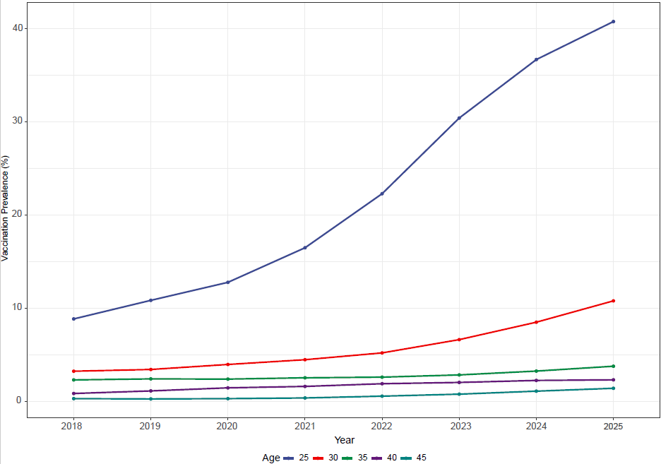
Figure X. Trends in HPV Vaccination Prevalence Among Veterans by Age, 2018–2025. HPV vaccination prevalence among Veterans aged 25–45 increased steadily from 2018 to 2025, with the largest gains among younger cohorts (ages 25–30) and persistently low uptake among those over 40. These data demonstrate the feasibility of tracking vaccination trends in the VHA and highlight age-related gaps targeted in this proposal.
We developed and tested a fully functional Agent-Based Model (ABM) to simulate the population health and economic impact of expanding HPV vaccination. The model represents a heterogeneous cohort of 10,000 simulated persons characterized by age, vaccination status, HPV infection history, smoking behavior, and other risk factors that mirror the real-world VHA population. Agents transition through key health states, Healthy, HPV infection, Persistent infection, Cancer (HPV+ OPC), and Death, based on published evidence. The ABM tracks HPV infections, OPC incidence, mortality, and healthcare costs under multiple vaccination policy scenarios, allowing direct comparison of outcomes when eligibility extends from age 26 to 30, 35, 40, and 45. As shown in Figure X, extending vaccination eligibility consistently reduced cumulative OPC cases, deaths, and total healthcare costs, demonstrating the model’s capacity to generate biologically and economically plausible results. However, without better inputs from veteran-specific populations, these findings confirm the feasibility of our simulation framework, and its readiness for full-scale implementation in Aims 2 and 3, we require additional inputs to evaluate the projected health and economic benefits of HPV vaccination expansion in the VHA.
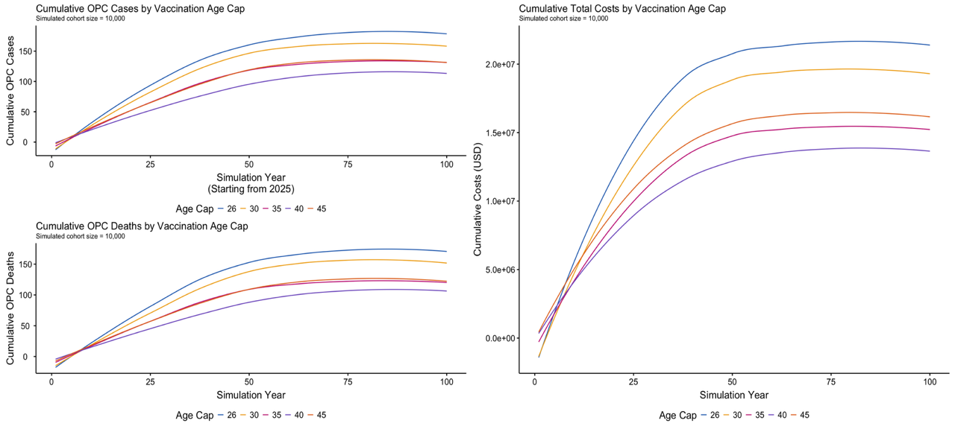
Figure X. Preliminary Simulation Results from the Veteran Agent-Based Model.
Simulations of 10,000 Veterans show that extending HPV vaccination eligibility beyond age 26 progressively reduces cumulative OPC cases (top left), OPC deaths (bottom left), and total healthcare costs (right), demonstrating the feasibility of the model.
Together, these preliminary analyses underscore both the feasibility and the urgency of this work. Our team has successfully demonstrated the ability to extract, link, and analyze HPV vaccination data from the VHA Corporate Data Warehouse, generate robust population-level estimates, and integrate these findings into a calibrated simulation model that reflects the unique characteristics of Veterans. The observed increase in vaccination uptake among younger Veterans, combined with persistently low coverage in older age groups, highlights a critical prevention gap that can be directly addressed through the proposed research. Our modeling framework shows clear potential to project the long-term health and economic benefits of expanded vaccination eligibility, providing actionable insights for VISN- and system-level implementation. This foundation positions us to build a comprehensive, Veteran-centered evidence base to guide future HPV vaccination strategies, strengthen cancer prevention infrastructure, and ultimately improve health outcomes across the VHA.

RESEARCH DESIGN AND METHODS
Conceptual Framework. The conceptual framework for this proposal connects Veteran-level characteristics, behavioral risk factors, and geographic access to preventive services with HPV vaccination uptake, modeled health outcomes, and projected economic impact across the VHA (Figure X). In this framework, individual demographic and behavioral factors—such as age, smoking, alcohol use, and engagement in preventive care—interact with contextual influences, including VISN region, rural–urban residence (RUCA codes), and census-tract–level spatial access to vaccination sites (SPARs), to shape when, where, and how Veterans receive HPV vaccination. Aim 1 applies this framework by estimating three related but distinct aspects of vaccination behavior among Veterans aged 26–45: the overall prevalence of HPV vaccination, the prevalence of Veterans who start vaccination after age 26 in any healthcare setting, and the proportion of previously unvaccinated Veterans who initiate vaccination within the VHA after age 26. By differentiating vaccination outside the VHA from vaccination provided by VA clinics, Aim 1 identifies which Veterans rely solely on the VA for mid-adult preventive services and highlights where access and uptake gaps are most significant across VISNs. These findings directly inform Aim 2, which employs Veteran-specific simulation models to estimate the potential public health benefits of expanding HPV vaccination eligibility, including reductions in HPV infections, OPC incidence, and downstream cancer mortality. The results from Aims 1 and 2 then feed into Aim 3, which assesses the economic impact of expanded vaccination efforts using VHA-specific data on costs, utilization, and demographics to estimate return on investment at the VISN level and across the entire system. This integrated framework links real-world vaccination patterns with predictive modeling and health economics, supporting the development of targeted, equitable HPV vaccination strategies tailored to Veterans' needs, especially those living in rural, low-access, or underserved regions VHA.
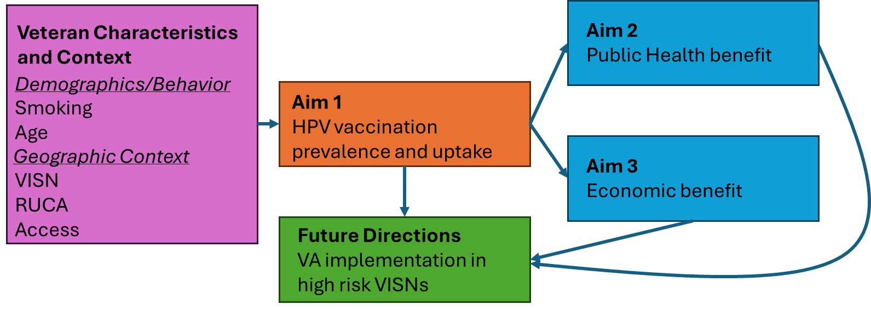
Figure X. Conceptual model of the proposed study. Veteran demographic, behavioral, and contextual factors, especially rural–urban residence and VISN-level access, affect HPV vaccination prevalence (Aim 1). These data inform models of health benefit (Aim 2) and economic impact (Aim 3), guiding evidence-based HPV vaccination policy across the VHA with a focus on rural access.

Aim 1. Determine the overall prevalence of HPV vaccinated Veterans aged 26-45 and measure current trends in HPV vaccine administration by the VHA in this age group.
Using data from the VHA Corporate Data Warehouse (CDW), we will characterize HPV vaccination patterns among Veterans aged 26–45 by estimating three complementary outcomes: the overall prevalence of HPV vaccination in this age group, the prevalence of Veterans who initiate HPV vaccination after age 26 in any healthcare setting, and the proportion of previously unvaccinated Veterans who initiate vaccination within the VHA after age 26. These measures provide a comprehensive understanding of mid-adult vaccination behavior, information that is critically needed because many Veterans enter VHA care in their late 20s or 30s, when HPV vaccination is no longer universally recommended but instead guided by shared clinical decision-making. Analyses will emphasize variation across census-tract RUCA codes, SPARs, and VISNs, which together capture geographic and system-level differences in access to preventive services. We hypothesize that HPV vaccination rates among Veterans remain low overall, with especially low uptake among Veterans at elevated risk for HPV-associated oropharyngeal cancer—particularly White male smokers, individuals with heavy alcohol use, and those living in rural, highly rural, or low-access (low-SPAR) census tracts. By distinguishing between vaccinations administered outside the VA and those administered within VA facilities, this aim will identify which Veterans rely exclusively on the VHA for adult vaccinations and reveal geographic regions where structural barriers and low vaccination uptake converge. These findings will enable the development of targeted, VISN-specific vaccination strategies and prevention initiatives that can directly inform VHA population health and policy.

Experimental Approach
We will construct a national cross-sectional study of Veterans aged 26–45 who had at least one primary-care visit between 2018 and 2025, ensuring that all participants are actively engaged with the VHA and eligible for HPV vaccination. In 2017, approximately 6.1 million Veterans had at least one VA visit, of which 1.7 million were under age 45, indicating a robust population base for analysis. Using the VHA CDW, we will identify all eligible Veterans, extract immunization data, and link these records to demographic, behavioral, and geographic information to characterize vaccination patterns across the national VHA population.²⁷ In addition to this cross-sectional cohort, we will construct a longitudinal inception cohort of Veterans who reached the age of 26 during the study period and had no documented HPV vaccination before that age. These vaccine-naïve Veterans will be followed forward through VHA records to estimate the proportion who initiate HPV vaccination within the VHA after age 26, providing the first systemwide characterization of adult vaccination uptake under shared clinical decision-making guidelines. This dual-cohort design allows us to distinguish between vaccinations occurring anywhere and those attributable specifically to VA-based preventive care.

HPV vaccination prevalence and uptake
HPV vaccination records will be obtained from the CDW immunization and pharmacy tables. Because historical dosing information and exact administration dates are incompletely captured, especially for vaccinations given outside the VHA, our primary outcome for the cross-sectional cohort will be any HPV vaccination (yes/no), which provides the most reliable measure of vaccine uptake across the entire population. Within this cohort, we will also classify Veterans as vaccinated before age 26 or after age 26, allowing us to distinguish early-life immunization from mid-adult vaccination under shared clinical decision-making. Dose number and timing will not be used as primary indicators for the cross-sectional cohort due to incomplete data; however, they will be summarized descriptively when available. In contrast, within the longitudinal cohort of vaccine-naïve Veterans who turn 26 during the study period, we will be able to track vaccinations over time, enabling complete capture of dose number, dose timing, and adherence to the recommended series. For this cohort, we will measure series initiation, receipt of 1, 2, or 3 doses, and adherence (defined as ≥2 doses), as well as adherence to recommended dosing intervals when dates are available. This dual approach allows us to reliably estimate overall vaccination patterns across the VHA while also generating detailed, prospective data on dosing, adherence, and series completion among Veterans who initiate HPV vaccination within the VHA after age 26.

Behavioral, demographic, and contextual predictors.
Behavioral and demographic variables will be derived from structured Health Factors and administrative data within the CDW and defined using validated phenotype algorithms from the VA CIPHER (Centralized Interactive Phenomics Resource) library to ensure reproducibility and consistency with VA data standards. Smoking status—a well-established risk factor for HPV-associated oropharyngeal cancer and a potential modifier of vaccine uptake—will be determined using the validated VHA Health Factors dataset, which is refreshed daily and routinely completed by providers in the electronic health record.^{28,29} Smoking will be categorized as current, former, or never at the index primary-care visit or within one year preceding it. To improve data completeness and validation, we will cross-reference smoking indicators with ICD-10 codes and pharmacy data for nicotine replacement therapy or smoking cessation prescriptions. Alcohol use will be captured using Health Factors fields and ICD-10 codes related to alcohol dependence or abuse, while comorbidities will be summarized using the Charlson and Elixhauser indices calculated from inpatient and outpatient diagnosis codes to assess the relationship between chronic disease burden and vaccine uptake. Demographic variables will include age, sex, race/ethnicity, marital status, and service connection percentage, which collectively provide key contextual factors influencing preventive health behaviors. Service connection percentage will serve as a proxy for disability status and healthcare utilization intensity, while marital status may reflect differences in social support that affect preventive care engagement.

Geospatial measures: rurality and access to vaccination.
Geographic analyses will link each Veteran’s residential address from the Medical SAS (MedSAS) inpatient and outpatient files to the corresponding U.S. Census tract using VA’s validated geocoding algorithms within the CDW. This allows linkage of individual-level data to tract-level indicators of rurality, spatial access to care, and socioeconomic context. Rurality will be quantified using Rural–Urban Commuting Area (RUCA) codes developed by the U.S. Department of Agriculture’s Economic Research Service and the University of Washington.³⁰ RUCA codes classify census tracts into 10 categories (1 = urban core, 10 = isolated rural) based on population density, urbanization, and commuting patterns. Following VA Office of Rural Health standards, these will be aggregated into four categories—urban, large rural, small rural, and isolated rural—consistent with existing VHA reporting conventions.
To evaluate geographic access to HPV vaccination, we will calculate Spatial Access Ratios (SPARs) at the census-tract level for all community-based outpatient clinics (CBOCs) and VA medical centers (VAMCs) that provide adult vaccination services.³¹ SPARs quantify accessibility by integrating clinic supply, Veteran population demand, and travel time. Using the Enhanced Two-Step Floating Catchment Area (E2SFCA) method, we will define supply as the number of VA facilities offering adult HPV vaccination and demand as the number of enrolled Veterans residing within each tract.³² The method accounts for overlapping service areas by weighting access based on travel time bands (0–20, 20–40, and 40–60 minutes) and applying distance-decay functions to reflect the decline in utilization with increasing travel time. SPAR values will be normalized within each state, where 1.0 indicates average access, values below 1.0 indicate limited access, and values above 1.0 represent greater-than-average accessibility. Each Veteran’s tract-level SPAR value will be linked to their individual record, allowing integration of both individual- and system-level geographic indicators into regression models.
We will analyze the combined effect of rurality and SPARs on vaccination rates to identify geographic disparities in HPV vaccine access. Interaction terms between RUCA category and SPAR will assess whether limited spatial access worsens the impact of rural residence on under-vaccination. Mapping will illustrate geographic clusters of low vaccination rates and poor access using choropleth maps and spatial autocorrelation measures (Getis-Ord Gi* and local Moran’s I). These maps will be created at both national and VISN levels to pinpoint areas where targeted efforts could have the greatest impact.

Statistical analysis.
We will estimate the overall prevalence of HPV vaccination and examine variations by VISN, demographic subgroup, behavioral risk factors, and census-tract characteristics, including rurality and SPARs. Descriptive analyses will summarize vaccination uptake and demographic distributions across the cross-sectional cohort. Unadjusted comparisons will use chi-square tests and prevalence differences with 95% confidence intervals. Temporal trends from 2018 to 2025 will be evaluated using joinpoint regression to estimate annual percent changes in vaccination prevalence, with particular attention to shifts following the 2019 shared clinical decision-making guidelines. Multivariable logistic and multinomial regression models will identify independent predictors of vaccination initiation (yes/no) and, where data permit, dose receipt and adherence. Covariates will include age, sex, race/ethnicity, marital status, service connection percentage, smoking, alcohol use, comorbidity burden, rurality, and SPAR, with VISN modeled as a random effect to account for geographic clustering. Interaction terms between SPAR and rurality will test whether spatial access modifies rural–urban disparities in vaccine uptake.
For the longitudinal inception cohort of vaccine-naïve Veterans entering VHA care at age 26, we will explicitly include time at risk in the denominator. Each Veteran will contribute person-time from their 26th birthday (or their first primary-care encounter after turning 26) until one of these events occurs: HPV vaccination at the VA, loss to follow-up, death, or the end of the study period. We will estimate the time to first HPV vaccination within the VHA using Kaplan–Meier survival curves and cumulative incidence functions. Mixed-effects Cox proportional hazards models will identify predictors of vaccination initiation within the VHA, with VISN as a random effect and the same set of demographic, behavioral, and geospatial covariates as previously described. This time-to-event approach enables accurate accounting for variable follow-up durations and models incident vaccination as a function of exposure to the VHA healthcare system.
To identify low-vaccination regions, we will calculate VISN-specific prevalence estimates (cross-sectional cohort) and VISN-specific incidence rates of VA-administered vaccination (inception cohort), comparing them across regions using mixed-effects models that account for the hierarchical nesting of Veterans within census tracts and VISNs. Within each VISN, we will map SPAR-adjusted vaccination prevalence and apply spatial clustering analyses (local Moran’s I and Getis-Ord Gi*) to detect statistically significant clusters of low vaccination and limited access. Regions with both low uptake and below-average SPARs will be identified as “vaccination deserts.” National and VISN-level heatmaps will be created, and VISNs ranked by adjusted vaccination prevalence and incidence. These results will produce the first VISN-resolved estimates of HPV vaccination uptake and access barriers among mid-adult Veterans and will provide key empirical data for simulation modeling in Aims 2 and 3.

Interpretation, implementation, and deliverables.
We anticipate HPV vaccination rates among Veterans aged 26–45 to remain low overall, with notable variation based on demographic, behavioral, and geographic factors. The lowest uptake is likely among White male Veterans who smoke or drink heavily and those living in rural or low-SPAR census tracts. We also expect significant differences at the VISN level, with the South-Central and Southeastern VISNs showing the lowest vaccination rates and the highest numbers of high-risk, rural Veterans. By distinguishing between Veterans vaccinated before age 26 and those beginning vaccination during mid-adulthood, Aim 1 will identify VISNs where mid-adult vaccination is uncommon and where Veterans depend more on non-VA settings for preventive immunization. Additionally, through the longitudinal vaccine-naïve cohort, we aim to identify VISNs and facilities where system-engaged Veterans turning 26 are least likely to start vaccination within the VHA, highlighting missed opportunities for VA-based preventive care. These analyses will identify high-risk groups and geographic “vaccination deserts,” providing practical evidence to guide VISN- and facility-specific interventions. The findings from this aim will directly inform VISN-specific vaccination campaigns and VHA population health initiatives. We will collaborate with VISN Preventive Health Leads, the Office of Rural Health, and the Office of Health Equity to review results, identify barriers, and develop strategies to improve HPV vaccination delivery, especially for mid-adult Veterans newly eligible through shared clinical decision-making. We will also work with Veteran Engagement Panels to ensure that recommended interventions reflect Veterans’ perspectives on preventive care, access barriers, and vaccination preferences. Results will be shared via internal VA channels, including the VHA Population Health Dashboard, VISN-level briefings, VA Research Week presentations, and peer-reviewed publications. Deliverables will include VISN-level HPV vaccination profiles (overall, pre-26, and post-26), geospatial maps showing areas with low vaccination rates and limited access, and datasets describing demographic, behavioral, and geographic factors influencing both vaccination uptake and VA-based series initiation. These will serve as essential baseline inputs for Aims 2 and 3, providing real-world VHA data to inform vaccination benefit models and assess the cost-effectiveness of extending HPV vaccination eligibility. Additionally, we will produce a policy brief for VHA leadership summarizing regional disparities and recommending VISN-specific strategies to strengthen vaccination infrastructure at community-based outpatient clinics (CBOCs), expand pharmacist-led vaccination programs, and incorporate HPV vaccination prompts into electronic health records. Overall, these deliverables will establish the empirical and operational basis for data-driven, Veteran-centered HPV vaccination policies across the VHA, enhancing capacity for equitable, preventive cancer care.

Aim 2: Model the potential public health benefit of extending the age of universal HPV vaccination eligibility in the VHA population.
Although HPV vaccination effectively prevents oral HPV infection and HPV-associated OPC, its population-level benefits have not been assessed within the unique demographic, behavioral, and healthcare context of Veterans. Existing studies in the general U.S. population underestimate the potential benefit of vaccination in Veterans because they do not account for later entry into the healthcare system, higher smoking prevalence, greater comorbidity burden, and absence of screening for OPC. As many Veterans enter the VHA between ages 26 and 45—after the traditional vaccination window—expanding vaccination eligibility within this age range may provide meaningful reductions in HPV infection and OPC incidence. To evaluate this possibility, we will use a Veteran-specific agent-based model (ABM) to simulate the health impact of alternative vaccination age thresholds, incorporating real-world demographic, behavioral, and VISN-level data obtained in Aim 1.

Experimental Approach
The ABM simulates HPV transmission, persistence, and OPC outcomes within the Veteran population. Each “agent” represents an individual Veteran characterized by attributes derived directly from Aim 1—age, sex, vaccination status, smoking, alcohol use, and VISN affiliation. Agents move through five health states (Healthy, HPV Infection, Persistent Infection, HPV-associated OPC, Death) according to probabilistic rules that reflect these risk factors. Vaccination reduces the probability of HPV infection and persistence, whereas smoking and alcohol use increase progression risk. This structure captures both individual heterogeneity and population-level dynamics across the VHA system.
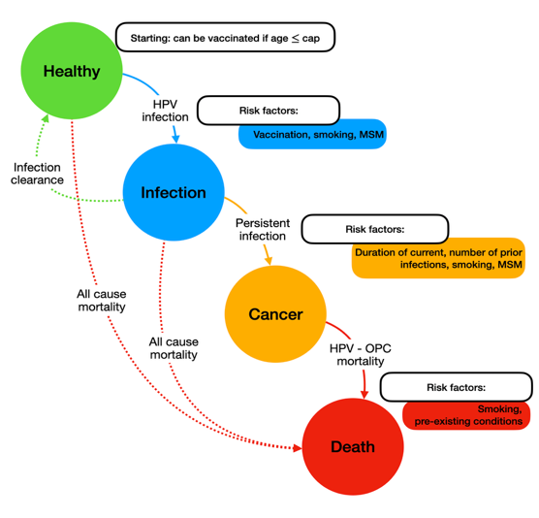
Figure X. Schematic of the HPV natural history model showing transitions from Healthy to Infection, Cancer, and Death, with pathways influenced by vaccination, infection clearance, and all-cause or HPV-OPC mortality. Key risk factors—including smoking, MSM status, prior infections, and comorbidities—modify the likelihood of transition between states.
The model will be parameterized with Aim 1 data, reflecting the distributions of age, sex, race/ethnicity, behavioral risk factors, vaccination prevalence, and adherence observed among Veterans aged 26–45 from 2018–2025. A synthetic cohort of 10 000 agents, calibrated to reflect the demographic makeup of the national Veteran population, will be generated by probabilistic sampling from these empirical distributions. Annual time steps over a lifetime 30-year horizon will capture near- and long-term effects of vaccination expansion. We will evaluate five policy scenarios: maintaining eligibility through age 26 (status quo) and expanding eligibility to ages 30, 35, 40, and 45. For each scenario, the ABM will estimate annual and cumulative numbers of HPV infections, persistent infections, OPC cases, and deaths.

Data Inputs and Calibration
Model inputs will derive primarily from Aim 1 to ensure internal consistency and Veteran specificity. The agent population will be initialized using joint distributions for demographic (age, sex, race/ethnicity, VISN) and behavioral (smoking, alcohol, comorbidity) factors and vaccination attributes (ever vaccinated, dose count, adherence ≥2 doses). Initialization will employ stratified sampling so that marginal totals and cross-tabs (e.g., age × VISN, smoking × vaccination) reproduce Aim 1 data. Baseline vaccination prevalence and adherence will be assigned separately by VISN to reflect observed heterogeneity.
Transition probabilities between health states (Healthy → Infection → Persistence → OPC → Death) will be guided whenever possible by associations quantified in Aim 1; parameters not available from Aim 1 will be imported from published literature. Parameters for vaccine efficacy in the 26–45 age group will be derived from randomized clinical trial data demonstrating robust immunogenicity and protection against persistent infection in mid-adult populations. To account for potential uncertainty regarding real-world effectiveness in Veterans, we will perform sensitivity analyses varying vaccine efficacy parameters across a range of plausible values. Calibration multipliers will then be applied so that model outputs reproduce overall and VISN-specific levels observed in Veterans. Calibration will proceed in two stages: (1) structural calibration, aligning the baseline year with Aim 1 targets for vaccination, smoking, and alcohol prevalence; and (2) dynamic calibration, refining imported transition probabilities so simulated trajectories mirror Aim 1 temporal patterns. Uncertainty will be addressed via 1,000 Monte Carlo iterations, reporting means and 95 % simulation intervals.

Simulation Scenarios
Primary outcomes will include reductions in OPC incidence, averted cancer deaths, and gains in quality-adjusted life years (QALYs).
Under the status quo scenario, Monte Carlo simulations (1,000 iterations) will be performed on the calibrated Veteran cohort to estimate the annual and cumulative numbers of HPV infections, persistent infections, and HPV-associated OPC cases and deaths across a 30-year projection period. Results will be summarized at the national and VISN levels, with standard errors and uncertainty bands calculated from simulation outputs. These baseline results will establish the expected disease trajectory if current vaccination practices remain unchanged.
We will then model a series of expanded vaccination eligibility scenarios in which HPV vaccination is extended to Veterans up to ages 30, 35, 40, and 45. For each scenario, vaccination coverage among newly eligible Veterans will be initialized based on age-specific vaccination and adherence rates derived from Aim 1, with additional assumptions about future uptake rates. Higher uptake will reduce the probability of transitioning from the Healthy to HPV Infection state, thereby decreasing the cumulative number of infections and subsequent OPC cases. Vaccine effectiveness for these mid-adult cohorts will be parameterized using end-of-study clinical trial data confirmed to prevent persistent infection and disease in adults aged 24–45. Outcomes will be compared across all scenarios to quantify relative reductions in infection prevalence, cancer incidence, and mortality.
Additionally, we will conduct behavioral sensitivity scenarios to assess how changes in vaccination rates over time impact projected outcomes. We will model both increases in vaccine uptake (reflecting improved outreach or VISN-specific programs) and decreases in vaccination rates (reflecting reduced access or declining public confidence). A decline in vaccination rates will increase the probability of HPV infection and persistence, leading to higher simulated OPC incidence. Comparing these opposing trends will help quantify how fluctuations in vaccination behavior could influence long-term cancer prevention outcomes.

Interpretation, Implementation, and Deliverables.
Extending HPV vaccination beyond age 26 is expected to produce stepwise reductions in HPV infection, persistence, and OPC incidence, with the greatest benefit under an age 45 expansion. Impact will vary by VISN according to baseline vaccination coverage and behavioral risk profiles. The ABM will serve as a dynamic decision-support tool that can be updated as new VHA data become available.
Implementation will occur in collaboration with the Office of Rural Health, Office of Health Equity, and VISN Preventive Health Leads to align outputs with operational needs. Each VISN will receive tailored summaries and dashboards showing projected reductions in HPV infection and OPC under different eligibility thresholds.
Deliverables will include a documented ABM framework hosted within the VA Informatics and Computing Infrastructure (VINCI), VISN-specific reports detailing modeled disease reductions, and a national policy brief summarizing projected public-health benefits of expanded vaccination eligibility. Model outputs—including infections, persistent infections, cancers, deaths prevented, and QALYs gained under each scenario—will serve as direct inputs for Aim 3’s economic evaluation. Together, these results will provide the VHA with a Veteran-specific, data-driven foundation for evaluating and implementing equitable, preventive HPV-vaccination strategies across the health-care system.

Aim 3. Assess the economic impact of extending HPV vaccination eligibility on the VA healthcare system.
OPC treatment places a significant economic burden on the VHA due to the intensive multimodal therapies, long-term survivorship needs, and disability-related expenses. Managing HPV-associated OPC often involves surgery, radiation, chemotherapy, immunotherapy, nutritional support, speech and swallowing therapy, and extended follow-up care. These clinical requirements lead to high direct medical costs along with indirect costs such as service connection, lost productivity, and long-term disability payments. Within the VHA, where Veterans tend to be older, have higher rates of smoking and comorbidities, and are often diagnosed at later stages, these costs can be even more substantial than in civilian healthcare systems.
Despite the increasing burden of HPV-positive OPC among Veterans, no study has assessed the cost-effectiveness of HPV vaccination specifically for this group. Existing cost-effectiveness models based on general population assumptions that do not reflect the demographic, behavioral, and clinical features of Veterans.^{11,33,34} These models presume a lower baseline cancer risk, younger age at entry into care, and greater herd immunity benefits than are likely applicable within the VHA. Furthermore, civilian models do not consider the VA’s integrated delivery system, disparities in access to care across VISNs, or the absence of any OPC screening method. Collectively, these gaps imply that the benefits of expanded vaccination could be considerably greater for Veterans.

Experimental Approach.
Building directly on the epidemiologic findings from Aim 1 and the Veteran-specific health outcome projections from Aim 2, Aim 3 will quantify the cost-effectiveness and budgetary consequences of expanding HPV vaccination eligibility to Veterans up to age 45. This aim will provide the first VHA-specific economic evaluation of adult HPV vaccination and generate actionable financial and policy evidence that can guide national prevention strategy across VISNs. Using the calibrated agent-based model (ABM) developed in Aim 2, we will integrate detailed cost and resource utilization data from the VA Health Economics Resource Center (HERC) to evaluate five vaccination policies: continuation of the status quo (vaccination through age 26) and expansion of universal vaccination to ages 30, 35, 40, and 45. For each scenario, the analysis will quantify program costs—including vaccine procurement, storage, distribution, and administration—and will estimate downstream healthcare expenditures averted through reductions in HPV infection, persistent infection, and HPV-associated OPC. We will complement the cost analysis with QALY gained estimates from Aim 2 to calculate incremental cost-effectiveness ratios (ICERs). The analysis will be conducted as per the recommendations of the Second Panel on Cost-Effectiveness in Health and Medicine, as well as VA-specific modeling standards.³⁵ Both one-way and probabilistic sensitivity analysis will be performed to identify the key drivers of cost-effectiveness and to assess the impact of parameter uncertainty on the probability that vaccination policies are cost-effective across a range of willingness-to-pay thresholds. In addition, we will project the net budget impact to the VHA over both 10- and 20-year horizons.
Specifically, the economic model will incorporate all epidemiologic inputs derived from Aims 1 and 2, ensuring internal consistency across components of the proposal. These inputs include age- and VISN-specific vaccination prevalence and adherence, smoking and alcohol use distributions, rurality stratified by RUCA codes, spatial access to vaccination measured by SPAR, HPV infection and persistence probabilities, OPC incidence and mortality, and QALY losses attributable to infection and cancer. The ABM will simulate a nationally representative cohort of 10,000 Veterans aged 26–45, reflecting real-world distributions across VISNs, demographic subgroups, and relevant behavioral risk factors. Cost inputs will be derived from HERC average cost files and will include vaccine acquisition and administration costs, clinic and pharmacy staffing time, treatment costs for OPC across all major modalities, long-term survivorship costs such as speech therapy, swallowing therapy, and feeding tube care, as well as end-of-life care. All costs will be adjusted to 2025 U.S. dollars using the medical Consumer Price Index.³⁶ QALYs will be estimated using utility weights from the Cost-Effectiveness Analysis Registry, augmented by Veteran-specific utility estimates for cancer treatment and survivorship. Both costs and QALYs will be discounted at 3% annually.
Primary analyses will estimate 30-year costs and QALYs under each vaccination strategy and will produce ICERs for expanded vaccination compared with the status quo. Vaccination strategies will be considered cost-effective if the ICER is below $100,000 per QALY gained and cost-saving if they improve health outcomes while reducing total costs.^{37,38} We anticipate that expansion to at least age 40—and likely age 45—will be cost-effective and may be cost-saving due to prevention of expensive late-stage OPC. Budget impact analyses will quantify annual and cumulative expenditures to the VHA over 10- and 20-year time horizons, accounting for VISN-specific differences in rurality, spatial access to vaccination, baseline vaccination infrastructure, and clinic capacity. These analyses will offer granular, geographically contextualized projections that reflect operational realities of implementing expanded vaccination within the VHA.
To assess uncertainty, we will conduct extensive sensitivity analyses. One-way sensitivity analyses will vary all uncertain parameters such as vaccine efficacy in mid-adults, uptake rates among newly eligible age groups, duration of vaccine-derived immunity, OPC treatment costs, and health-state utilities. Probabilistic sensitivity analysis using Monte Carlo simulation will jointly vary all uncertain parameters and generate uncertainty intervals surrounding ICERs and budget impact estimates. Scenario analyses will stratify results by VISN, rurality, and SPAR-defined access to care to identify geographic areas where expanded vaccination delivers the highest value per dollar invested.
We expect expanded HPV vaccination to substantially reduce HPV infections and OPC incidence, generate meaningful QALY gains, and produce favorable ICERs across most VISNs, with the greatest economic and health benefits in rural and low-access regions. Deliverables from this aim will include VISN-specific cost-effectiveness profiles, a VINCI-hosted interactive dashboard summarizing costs, QALYs, ICERs, and projected reductions in cancer burden, and a national policy brief synthesizing financial and clinical implications. We will also develop implementation recommendations for electronic health record prompts, VISN-tailored outreach strategies, and integration of HPV vaccination into separation-from-service evaluations and routine primary care workflows. Together, these findings will provide the first comprehensive, Veteran-specific economic evidence base to support expanded HPV vaccination policy across the VHA and guide systemwide investments in cancer prevention.

IMPLEMENTATION AND DISSEMINATION PLAN
The current proposal presents a crucial opportunity to prevent future oropharyngeal cancers and reduce morbidity among Veterans by improving the implementation of HPV vaccination. The rapid rise in HPV-related OPC, combined with the high costs of complex, late-stage treatment, creates an increasing and unpredictable burden for the VHA. This project will develop a Veteran-specific evidence base that includes national estimates of HPV vaccination rates, patterns of vaccination in early versus mid-adulthood, and the first longitudinal estimates of HPV vaccination initiation among previously unvaccinated Veterans entering VHA primary care. Along with a calibrated simulation model, these data will help quantify the potential health benefits of expanding HPV vaccination eligibility and project the economic impact of broader mid-adult vaccination at the VISN and national levels. Overall, the findings will provide a data-driven foundation for national prevention strategies that can be quickly integrated into existing VHA population health and primary care programs.
Our study focuses exclusively on Veterans aged 26–45, an age group currently outside routine HPV vaccination recommendations, yet representing a critical window for cancer prevention as many transition from active duty into VHA care. By identifying where mid-adult vaccination is occurring, where it is lacking, and where Veterans depend solely on the VHA for adult vaccination, the findings from Aim 1 will directly inform VISN- and facility-level implementation strategies. If successful, this project will deliver practical tools for improving HPV vaccination delivery across the VHA, strengthen shared clinical decision-making processes, and support the development of policies to ensure equitable access to mid-adult preventive services.

VA National and Program Office Priorities
This project directly advances VA national priorities in cancer prevention, equitable care access, and population health improvement. By identifying demographic, behavioral, and geographic barriers to HPV vaccination—and simulating the potential health and economic benefits of expanding eligibility—this study addresses disparities in preventive care among Veterans, especially those in rural or low-access VISNs. The findings will also support ongoing efforts by the Office of Rural Health, Office of Health Equity, and National Oncology Program Office to enhance cancer prevention, survivorship care, and geographic equity.
This work aligns with VHA’s strategic goals by implementing proactive, data-driven prevention strategies. VISN leadership can use findings from Aim 1 to identify regions with the lowest HPV vaccination rates, the lowest rates of mid-adult vaccination initiation, and the highest burden of risk factors such as smoking. The simulation and economic models in Aims 2 and 3 will further inform resource allocation and help VHA leadership prioritize preventive services that reduce future cancer cases and improve long-term Veteran health outcomes.

Long-Term Usage and Goals
We will broadly share findings with the scientific community, VA leadership, and the public. Data and results will be distributed to the National Oncology Program Office, Office of Research and Development, VISN Preventive Health Leads, and the Office of Rural Health to support ongoing program planning. We will publish results in peer-reviewed journals, present at VA Research Week and national scientific conferences, and collaborate with the VHA Oropharyngeal Cancer Working Group to translate findings into operational policies. Modeling tools, code, and analytic datasets will be accessible through the VA Informatics and Computing Infrastructure (VINCI), enabling future researchers and operational partners to build upon this work.
Each aim includes short- and long-term goals that directly support improvements in Veteran health:
Aim 1: Short-term — Define national HPV vaccination prevalence; distinguish vaccination before age 26 from vaccination during mid-adulthood; and identify VISN-level demographic, behavioral, and geographic barriers to both vaccine uptake and VA-based mid-adult vaccination initiation. Long-term — Inform VISN-specific vaccination initiatives, expand vaccination opportunities within CBOCs, and support integration of HPV vaccination reminders and prompts into the VHA electronic health record.
Aim 2: Short-term — Develop and calibrate a Veteran-specific agent-based model (ABM) to simulate the impact of expanding HPV vaccination eligibility to ages 30, 35, 40, and 45. Long-term — Use simulation outputs to project reductions in HPV infection, OPC incidence, cancer deaths, and quality-adjusted life years (QALYs) gained across VISNs. The model will serve as a dynamic decision-support tool for VHA leadership.
Aim 3: Short-term — Evaluate the economic impact and cost-effectiveness of extended HPV vaccination eligibility using real-world Veteran data. Long-term — Provide VHA and VISN leadership with actionable cost, QALY, and budget impact estimates to inform national vaccination policy and optimize preventive resource allocation.
Collectively, these aims will yield an integrated framework to support data-driven prevention and policy decisions across the VHA, directly reducing long-term cancer burden and associated costs.

Future Directions
This project lays the foundation for a sustainable, Veteran-centered HPV prevention infrastructure. Over time, we plan to create a Veteran Immunization Data Analytics (VIDA) platform that combines HPV vaccination data—and eventually other adult immunizations—across VISNs to monitor vaccination rates, identify under-vaccinated groups, and evaluate the effectiveness of ongoing prevention efforts. By providing VISN-level and national dashboards, VIDA would aid upcoming vaccination campaigns and serve as a scalable model for tracking additional preventive health metrics within the VHA. The ultimate goal of this research is to increase HPV vaccination rates among eligible Veterans, reduce HPV-related OPC cases, and strengthen the system’s capacity to deliver equitable, proactive preventive care. By leveraging existing VHA data systems and operational networks, this project makes a significant step toward eradicating preventable HPV-related cancers and enhancing long-term health outcomes for Veterans nationwide.

PROJECT MANAGEMENT
The proposed project will be managed through a structured, team-based approach that ensures scientific rigor, timely progress, and efficient coordination across all aims. Dr. Jose Zevallos (PI) will provide overall leadership, scientific direction, and oversight of all study components, with support from a multidisciplinary team with expertise in VA data analytics, epidemiology, biostatistics, health economics, and Veteran-focused implementation.

Leadership and Governance
Dr. Zevallos will hold standing project meetings every two weeks to review progress, address challenges, and coordinate analysis and dissemination activities. Dr. Angela Mazul will play a key leadership role in Aim 1 and throughout the project. She will co-lead cohort construction, oversee the development and coding of essential epidemiologic variables, and direct the integration of demographic, behavioral, and contextual measures from the VHA Corporate Data Warehouse. Dr. Mazul will guide analytic specifications, ensure methodological rigor in study design, and lead the interpretation of epidemiologic and geospatial findings across VISNs. Dr. Soumik Purkayastha will oversee analytic pipelines, statistical modeling, and simulation calibration within the VINCI environment. Dr. Moria Mor will manage all VA data operations, including cohort construction, data quality checks, variable harmonization, and compliance with VA data governance standards. Dr. Praveen Kumar will oversee economic modeling, including parameter selection, cost inputs, sensitivity analyses, and interpretation of incremental cost-effectiveness results. Dr. Jessica Maxwell will provide clinical guidance, ensure translational relevance, and support the interpretation of vaccination patterns and HPV-OPC burden estimates.

Workflow and Coordination
The project will follow a structured plan with coordinated milestones across aims. In Year 1, the team will finalize phenotype definitions, complete data extraction, construct analytic files, and finish Aim 1 analyses. Findings from Aim 1 will be directly used as inputs for Aim 2 simulations. In Year 2, the team will complete model calibration, validate simulation outputs, and perform all public health benefit and economic analyses for Aims 2 and 3. Data will be stored and analyzed solely within VINCI, adhering to all VA privacy and security guidelines. The PI and Co-Is will jointly review analytic code, model assumptions, and data outputs to ensure reproducibility and accuracy.

Project Timeline
This 4-year project will proceed in three integrated phases aligned with Aims 1–3. In Year 1, we will obtain all necessary VA approvals (DART, IRB, VINCI access) and extract analytic datasets from the Corporate Data Warehouse. We will complete data cleaning, construct cross-sectional cohorts, derive demographic, behavioral, geospatial, and VISN-level variables, and create the longitudinal vaccine-naïve cohort. Preliminary descriptive analyses will estimate the overall HPV vaccination prevalence among Veterans aged 26–45, compare vaccination rates before and after age 26, and generate early incidence estimates of VA-administered vaccination within the vaccine-naïve cohort (Aim 1). In Year 2, we will finalize multivariable analyses for Aim 1, complete time-to-event modeling in the vaccine-naïve cohort, and develop VISN-level maps identifying geographic vaccination gaps and access barriers. These results will serve as key inputs for parameterizing the simulation model, with model calibration and validation initiated and completed by the end of Year 2. In Year 3, we will conduct full simulations under multiple vaccination eligibility and uptake scenarios, estimating reductions in HPV infection, OPC incidence, cancer mortality, and QALYs gained across VISNs (Aim 2). Concurrently, we will begin Aim 3 by linking simulation outputs with VA HERC cost data to start cost-effectiveness and budget impact analyses. In Year 4, we will finalize the economic modeling, perform sensitivity and scenario analyses, and translate findings into actionable VISN-level and national policy recommendations. Deliverables include VISN-specific policy briefs, analytic datasets, scientific manuscripts, and presentations to VHA leadership. Cross-aim integration, dissemination, and preparation for renewal and implementation proposals will be completed in the final quarter of Year 4.

 | Year 1 |  |  |  | Year 2 |  |  |  | Year 3 |  |  |  | Year 4
Activity / Milestone | Q1 | Q2 | Q3 | Q4 | Q1 | Q2 | Q3 | Q4 | Q1 | Q2 | Q3 | Q4 | Q1 | Q2 | Q3 | Q4
Administrative & Regulatory Approvals
Data Extraction & Cohort Construction
Aim 1: Analyses
Aim 1: VISN-Level Mapping
Aim 2: ABM Parameterization
Aim 2: Simulation of Scenarios
Aim 2: Analysis of Outcomes
Aim 3: Economic Analysis
Aim 3: Break-even Analyses
Integration & Policy Translation
Dissemination

1. Ang KK, Harris J, Wheeler R, et al. Human papillomavirus and survival of patients with oropharyngeal cancer. N Engl J Med. Jul 1 2010;363(1):24-35. doi:10.1056/NEJMoa0912217
2. Chaturvedi AK, Engels EA, Pfeiffer RM, et al. Human papillomavirus and rising oropharyngeal cancer incidence in the United States. J Clin Oncol. Nov 10 2011;29(32):4294-301. doi:10.1200/JCO.2011.36.4596
3. Van Dyne EA, Henley SJ, Saraiya M, Thomas CC, Markowitz LE, Bernard VB. Trends in Human Papillomavirus–Associated Cancers — United States, 1999–2015. MMWR Morb Mortal Wkly Rep. 2018;67:918-924.
4. Agalliu I, Gapstur S, Chen Z, et al. Associations of Oral α-, β-, and γ-Human Papillomavirus Types With Risk of Incident Head and Neck Cancer. JAMA Oncology. 2016;2(5):599-606. doi:10.1001/jamaoncol.2015.5504
5. Gillison ML, Chaturvedi AK, Anderson WF, Fakhry C. Epidemiology of Human Papillomavirus-Positive Head and Neck Squamous Cell Carcinoma. J Clin Oncol. Oct 10 2015;33(29):3235-42. doi:10.1200/JCO.2015.61.6995
6. Meites E, Szilagyi PG, Chesson HW, Unger ER, Romero JR, Markowitz LE. Human Papillomavirus Vaccination for Adults: Updated Recommendations of the Advisory Committee on Immunization Practices. MMWR Morb Mortal Wkly Rep. Aug 16 2019;68(32):698-702. doi:10.15585/mmwr.mm6832a3
7. Boersma P, Black LI. Human Papillomavirus Vaccination Among Adults Aged 18-26, 2013-2018. NCHS Data Brief. Jan 2020;(354):1-8.
8. United States Department of Veterans Affairs. Office of Rural Health: Rural Veteran Health Care Challenges. Accessed August 9, 2020. https://www.ruralhealth.va.gov/aboutus/ruralvets.asp
9. Washington DL. National Veteran Health Equity Report 2021. Focus on Veterans Health Administration Patient Experience and Health Care Quality. VHA Office of Health Equity; 2022. https://www.va.gov/HEALTHEQUITY/docs/NVHER_2021_Report_508_Conformant.pdf
10. Zevallos JP, Kramer JR, Sandulache VC, et al. National trends in oropharyngeal cancer incidence and survival within the Veterans Affairs Health Care System. Head Neck. Jan 2021;43(1):108-115. doi:10.1002/hed.26465
11. Kim JJ, Simms KT, Killen J, et al. Human papillomavirus vaccination for adults aged 30 to 45 years in the United States: A cost-effectiveness analysis. PLoS Med. Mar 2021;18(3):e1003534. doi:10.1371/journal.pmed.1003534
12. Laprise JF, Chesson HW, Markowitz LE, et al. Effectiveness and Cost-Effectiveness of Human Papillomavirus Vaccination Through Age 45 Years in the United States. Ann Intern Med. Jan 7 2020;172(1):22-29. doi:10.7326/m19-1182
13. Pratama AP, Chen SF, Liao SC, Su WC, Yu JH. Incremental net benefit of extending human papillomavirus vaccine to boys in oropharyngeal cancer burden: Meta-analysis of cost-effectiveness studies. J Dent Sci. Oct 2024;19(4):2045-2056. doi:10.1016/j.jds.2024.05.032
14. Castle PE. Prophylactic human papillomavirus vaccination for prevention of oropharyngeal cancer in older men: is the juice worth the squeeze? J Natl Cancer Inst. Apr 11 2023;115(4):349-351. doi:10.1093/jnci/djad025
15. Choi SE, Choudhary A, Huang J, Sonis S, Giuliano AR, Villa A. Increasing HPV vaccination coverage to prevent oropharyngeal cancer: A cost-effectiveness analysis. Tumour Virus Res. Jun 2022;13:200234. doi:10.1016/j.tvr.2021.200234
16. Saxena K, Dawson RS, Cyhaniuk A, Bello T, Janjan N. Clinical and economic burden of HPV-related cancers in the US veteran population. Journal of Medical Economics. 2022/12/31 2022;25(1):299-308. doi:10.1080/13696998.2022.2041855
17. Jacobson JJ, Epstein JB, Eichmiller FC, et al. The cost burden of oral, oral pharyngeal, and salivary gland cancers in three groups: commercial insurance, Medicare, and Medicaid. Head Neck Oncol. 2012;4:15. doi:10.1186/1758-3284-4-15
18. Zevallos JP, Sandulache VC, Hamblin J, et al. Impact of race on oropharyngeal squamous cell carcinoma presentation and outcomes among veterans. Head Neck. Jan 2016;38(1):44-50. doi:10.1002/hed.23836
19. Nobel T, Rajupet S, Sigel K, Oliver K. Using Veterans Affairs Medical Center (VAMC) data to identify missed opportunities for HPV vaccination. Hum Vaccin Immunother. 2019;15(7-8):1878-1883. doi:10.1080/21645515.2018.1559684
20. Freedman MS, Hunter P, Ault K, Kroger A. Advisory Committee on Immunization Practices Recommended Immunization Schedule for Adults Aged 19 Years or Older — United States, 2020. MMWR Morb Mortal Wkly Rep. 2020;69:133-135.
21. Halista CE, Kline RJ, Bepko J. Understanding Barriers to HPV Vaccination: Perspectives From Air Force Family Medicine Physicians and Active Duty Air Force Males. Mil Med. 2020;185(5-6):e878-e886. doi:https://doi.org/10.1093/milmed/usz403
22. Masel J, Deiss RG, Wang X, et al. Seroprevalence and seroincidence of herpes simplex virus (2006-2010), syphilis (2006-2010), and vaccine-preventable human papillomavirus subtypes (2000-2010) among US military personnel. Sex Transm Dis. May 2015;42(5):253-8. doi:10.1097/olq.0000000000000277
23. Brown DW. Smoking prevalence among US veterans. Journal of general internal medicine. Feb 2010;25(2):147-9. doi:10.1007/s11606-009-1160-0
24. Odani S, Agaku IT, Graffunder CM, Tynan MA, Armour BS. Tobacco Product Use Among Military Veterans - United States, 2010-2015. MMWR Morb Mortal Wkly Rep. Jan 12 2018;67(1):7-12. doi:10.15585/mmwr.mm6701a2
25. Wang ZJ, Dhanireddy P, Prince C, Larsen M, Schimpf M, Pearman G. 2019 Survey of Veteran Enrollees’ Health and Use of Health Care – Data Findings Report. Accessed August 9, 2020. https://www.va.gov/HEALTHPOLICYPLANNING/SOE2019/2019_Enrollee_Data_Findings_Report-March_2020_508_Compliant.pdf
26. Chidambaram S, Chang SH, Sandulache VC, Mazul AL, Zevallos JP. Human Papillomavirus Vaccination Prevalence and Disproportionate Cancer Burden Among US Veterans. JAMA Oncol. May 1 2023;9(5):712-714. doi:10.1001/jamaoncol.2022.7944
27. United States Department of Veterans Affairs. National Center for Veterans Analysis and Statistics: VA Utilization Profile FY 2017. Accessed August 9, 2020. https://www.va.gov/vetdata/docs/Quickfacts/VA_Utilization_Profile_2017.pdf
28. McGinnis KA, Brandt CA, Skanderson M, et al. Validating smoking data from the Veteran's Affairs Health Factors dataset, an electronic data source. Nicotine Tob Res. 2011;13:1233-1239.
29. Golden SE, Hooker ER, Shull S, et al. Validity of Veterans Health Administration structured data to determine accurate smoking status. Health Informatic J. 2020;26(3):1507-1515.
30. U.S. Department of Agriculture. 2020 Rural-Urban Commuting Area Codes. In: Service ER, editor. July 2025.
31. Muluk S, Sabik L, Chen Q, Jacobs B, Sun Z, Drake C. Disparities in geographic access to medical oncologists. Health Serv Res. Oct 2022;57(5):1035-1044. doi:10.1111/1475-6773.13991
32. Luo W, Qi Y. An enhanced two-step floating catchment area (E2SFCA) method for measuring spatial accessibility to primary care physicians. Health Place. Dec 2009;15(4):1100-7. doi:10.1016/j.healthplace.2009.06.002
33. Landy R, Haber G, Graubard BI, et al. Upper age limits for US male human papillomavirus vaccination for oropharyngeal cancer prevention: a microsimulation-based modeling study. J Natl Cancer Inst. Apr 11 2023;115(4):429-436. doi:10.1093/jnci/djad009
34. Damgacioglu H, Sonawane K, Chhatwal J, et al. Long-term impact of HPV vaccination and COVID-19 pandemic on oropharyngeal cancer incidence and burden among men in the USA: A modeling study. Lancet Reg Health Am. Apr 2022;8:100143. doi:10.1016/j.lana.2021.100143
35. Sanders GD, Neumann PJ, Basu A, et al. Recommendations for Conduct, Methodological Practices, and Reporting of Cost-effectiveness Analyses: Second Panel on Cost-Effectiveness in Health and Medicine. Jama. Sep 13 2016;316(10):1093-103. doi:10.1001/jama.2016.12195
36. Office of Publications and Special Studies. BLS Data Viewer. https://data.bls.gov/dataViewer/view/timeseries/CUUR0000SAM
37. Braithwaite RS, Meltzer DO, King JT, Jr., Leslie D, Roberts MS. What does the value of modern medicine say about the $50,000 per quality-adjusted life-year decision rule? Med Care. Apr 2008;46(4):349-56. doi:10.1097/MLR.0b013e31815c31a7
38. Neumann PJ, Cohen JT, Weinstein MC. Updating cost-effectiveness--the curious resilience of the $50,000-per-QALY threshold. N Engl J Med. Aug 28 2014;371(9):796-7. doi:10.1056/NEJMp1405158

